Ensuring Convenience and Safety: The Role of Mobile Catering Apps in Modern Food Delivery in Indonesia

Yeremia Soeharto
Digital Business Innovation Department, Binus Business School
Bina Nusantara University
Bandung Campus
Bandung, Indonesia
yeremia.soeharto@binus.ac.id
Marcello Setiawan
Digital Business Innovation Department, Binus Business School
Bina Nusantara University
Bandung Campus
Bandung, Indonesia
marcello.setiawan@binus.ac.id
Ikrar Adinata Arin
Information System Department,
School of Information Systems
Bina Nusantara University
Jakarta, Indonesia
ikrar@binus.ac.id

Abstract— In recent years, the rapid growth of mobile technology has revolutionized the food delivery industry in Indonesia, particularly through the development of mobile catering applications. This paper explores the dual role of these apps in ensuring both convenience and safety for users, a critical concern in the post-pandemic era. By offering seamless food ordering, personalized recommendations, and real-time tracking, mobile catering apps have transformed consumer dining habits. Additionally, the paper investigates the safety measures embedded within these platforms, including contactless payment systems, hygiene protocols, and delivery safety features. Through a comprehensive analysis of user experiences and industry practices, this study highlights how mobile catering apps have adapted to the evolving demands of Indonesian consumers, emphasizing their potential in shaping the future of food delivery. The findings underscore the importance of integrating user-friendly features and strict safety guidelines to build trust and enhance customer satisfaction in this growing market.
Keywords—Mobile Catering Applications, Mobile Technology in Catering, Digital Platforms for Food Service

Introduction
Mobile gadgets are widely used in today's society. Android is a prominent operating system among mobile device producers nowadays [1, 2]. Global smartphone users are anticipated to reach 2.53 billion in 2018, 2.71 billion in 2019, and 2.87 billion in 2020 [3, 4]. Leveraging smartphone, many developers are designing and building applications tailored to specific needs, including those in the culinary industry [5, 6, 7]. The growth of online businesses is a result of advancements in information and communication technology, which are increasingly becoming a necessity in the business world [8, 9]. In 2014, the "business" category was the most popular app category on the Apple iOS platform, with "food and drink" being the second fastest-growing category (Ariel, 2015). This "food and drink" category includes numerous "catering apps" or restaurant apps offered by food and beverage companies. [10, 11, 12]

Catering is one of the culinary industries that is constantly expanding and in high demand, particularly for events such as weddings, organizational celebrations, and other large gatherings [13, 14]. As catering businesses grow and expand into business chains, companies can gain a competitive edge by adopting a business model tailored to differentiated catering product markets. Mobile catering offers an excellent opportunity to boost restaurant sales or enter the catering market. Mobile technology plays a significant role in driving innovation within the service industry [15, 16, 17].

Consumers who are increasingly trained and educated with the use of the internet is becoming a potential market for many businesses [18, 19]. According to APJII (Indonesia Association of Internet Service Providers) internet users in Indonesia in April 2013 have been recorded around 63 million people [20, 21]. However, application-based catering ordering systems are still not widely employed, particularly in Indonesia. Most catering businesses are home-based and primarily depend on word-of-mouth recommendations from personal contacts or promoting through brochures to attract potential customers [1, 22, 23, 24]. Due to these conditions, the purpose of the current research is to develop a business model of a catering application, which can help users and catering service providers to conduct transactions more safely and effectively.

Related Works
We conducted a simple literature review covering developments in mobile catering apps in Indonesia over the past ten years. Our aim was to understand the role of mobile catering apps in ensuring convenience and safety within modern food delivery services. We achieved this by analyzing and collecting relevant research from databases such as Google Scholar and Scopus, as well as using AI-based academic tools, namely Publish or Perish. Through this method, we identified significant developments, emerging trends, and gaps in the literature, providing a solid foundation for our exploration into how mobile catering apps contribute to enhancing convenience and safety in Indonesia’s food delivery industry.
Based on previous research by Wang, Y.-S., when it comes to developing successful catering apps, it is essential to prioritize system quality, which significantly impacts perceived value and user satisfaction. This finding underscores the need for designers to enhance user-friendliness, reliability, and responsiveness, as these attributes are crucial for meeting consumer expectations for convenience in meal ordering. Moreover, perceived promotions and pricing strategies play vital roles in app success; collaborating with marketing teams to create attractive mobile coupons can foster consumer loyalty. Additionally, maintaining above-average product quality is critical for user satisfaction, as high-quality offerings encourage repeat use and positive electronic word-of-mouth unavoidable [3, 25, 26].

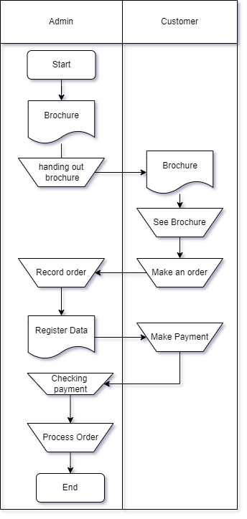
Syani M. & Werstantia N. once analyzed Cimahi Catering as a case study to explore the catering system in Indonesia; here are the results of their findings on their research.
FIGURE I. CIMAHI CATERING SYSTEM FLOW
The image above represents the current workflow for ordering catering services. The process includes:
- Cimahi Catering distributes its brochures. Interested customers will either call or visit the location directly to place a catering order.
- The customer’s order, along with their information, will be recorded manually by the Admin.
- The customer makes a payment, with the condition of providing a down payment (DP) or full payment (FP).
- Cimahi Catering checks the incoming payments, whether in cash or via bank transfer.
- Once the payment is confirmed, the order will be processed by Cimahi Catering.
- After the order is processed, it will be delivered to the customer’s address.

From the process description above, there are shortcomings, as customers will need more time and money to place an order. On the admin side, the conventional method of record-keeping carries the risk of errors in recording and calculation [1, 27, 28].

According to the research conducted by Sulastri E., Yudha D., and Efrat A., users require several key features when developing a mobile catering application [29, 30, 31].
No | Features | Purpose
1 | Search | Can search for catering and menus.
2 | View Menu Descriptions | Can view detailed information related to the catering menus available in the application.
3 | Order | Can place catering orders through the application.
4 | Payment | Can make payments for the order.
5 | Order Tracking | Can track the status of the order until the delivery is completed.
6 | Order History | Can view history catering orders that ever placed in the application.
7 | Chat | Media Communication between seller and customer.
8 | Notification | Catering seller can see notification and reminder about catering order.
9 | Review and Rating | Can add and review user rating after placing a catering order.
10 | Request Menu | Can choose a custom menu, aside from the packages provided by the catering service.
11 | Catering Registration | Catering sellers can register catering on the application.
12 | Manage Catering Menu | Catering sellers can add menu and change the information about the menu.
13 | Manage Sales | Catering sellers can see and change sales status.
14 | Income Information | The catering owner can view the income from catering orders.
TABLE I. USER FEATURES NEED

Methodology
Based on several related works, we try to apply the Design Thinking (DT) method, namely the Double Diamond by Design Council UK.

Double Diamond method is a design framework that guides teams in identifying key problems and building practical solutions step-by-step. It follows four main stages: Discover, Define, Develop, and Deliver [32, 33].

DT Step | Description | Output
- Discover  - Define  - Develop  - Deliver | In this stage, the researcher gather insights to see the problem from different angles  The researcher must shape a clear problem statement from this information  In this stage, the researcher must brainstorm and test out different solutions  Finally, the researcher must choose the most effective solution and put it into action | Use Case  Data Flow, ERD  Class Diagram, Sequence Diagram, Wireframe  Design
TABLE II. THE RESEARCH STAGE OF DOUBLE DIAMOND METHOD

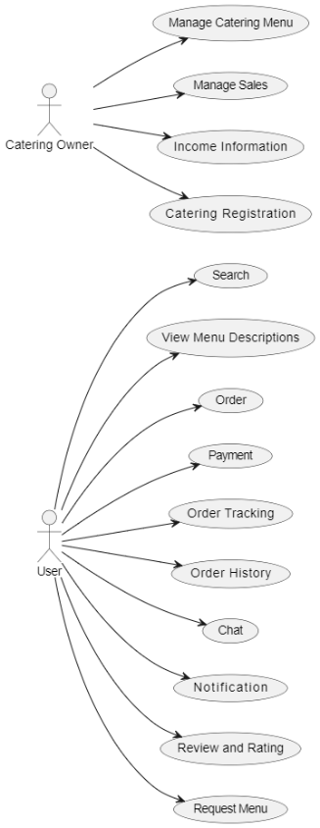
Use Case
FIGURE II. USE CASE DIAGRAM
Actors:
- User: The regular customer who uses the app to look for menus, place orders, track deliveries, and give feedback.
- Catering Owner: The business owner who manages their catering service on the app—registering their business, setting up menus, tracking sales, and viewing income reports.

Users:
- Search: Users can search for catering services or specific dishes in the app.
- View Menu Descriptions: They can read details about each menu item, such as ingredients and prices.
- Order: Users can place their food or catering orders directly in the app.
- Payment: After ordering, they can make payments through the app using different payment methods.
- Order Tracking: Users can check the status of their order, from the kitchen to delivery.
- Order History: They can also view past orders for easy reordering.
- Chat: Users can chat with the catering provider or admin to ask questions or confirm details.
- Notification: They receive updates about their order status, special offers, or important news.
- Review and Rating: After receiving their food, users can leave a rating and review for the catering service.
- Request Menu: If they don’t find what they’re looking for, users can request specific dishes or custom orders.

Catering Owners
- Catering Registration: Catering owners can register their business on the app so it can be found by customers.
- Manage Catering Menu: They can easily add, edit, or remove menu items to keep their offerings up to date.
- Manage Sales: Owners can track their sales and orders coming through the app.
- Income Information: They can review income reports to see how well their business is doing financially.

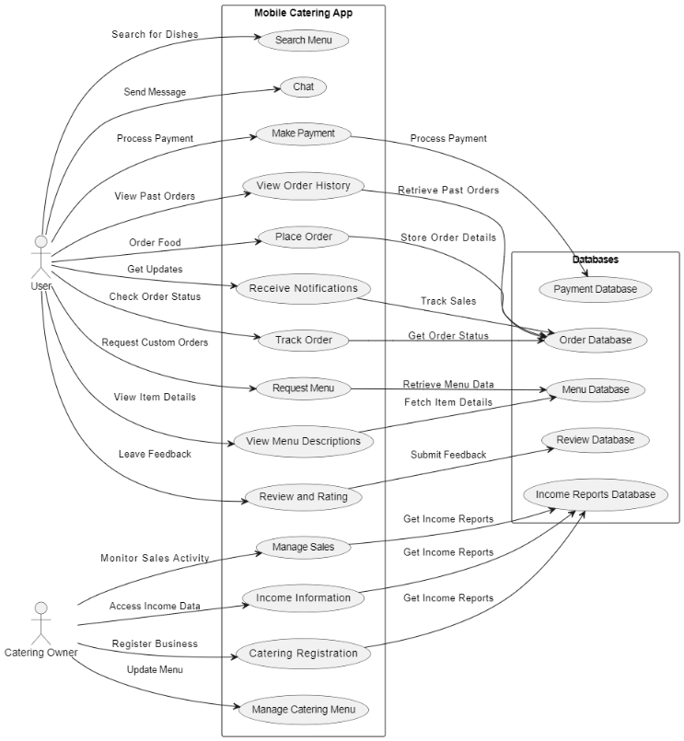
Data Flow

FIGURE III. DATA FLOW DIAGRAM

Figure III illustrates the Data Flow Diagram (DFD) for the mobile catering application designed to enhance food delivery services in Indonesia, the left side showcases the primary actors involved: Users and Catering Owners. These actors interact with the system through a series of defined processes, including searching for menus, placing orders, making payments, and providing feedback. The processes extend to the right, where they are linked to corresponding databases that store essential information, such as menu details, order records, payment transactions, and user reviews.

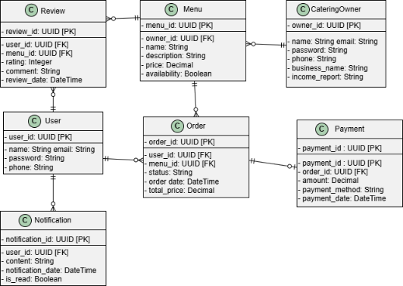
ERD

FIGURE IV. ENTITY RELATIONSHIP DIAGRAM

Figure IV illustrates about Entity Relationship Diagram (ERD) for Customers to place their orders, check their order history, and even chat directly with catering providers if they have questions. Catering owners can register their businesses, manage their menus, and keep an eye on sales and income reports, making it simple to run their catering services. Admins are there to support the catering owners by helping manage menus and track sales activities. With helpful features like notifications and customer reviews, the app fosters better communication between users and catering providers, ultimately enhancing satisfaction and streamlining operations in the catering community.

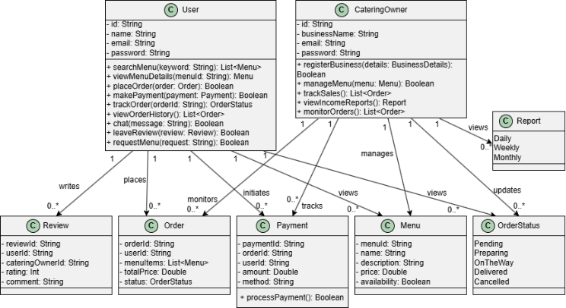
Class Diagram

FIGURE V. CLASS DIAGRAM

Figure V presents the Class Diagram for the mobile catering app, showcasing the primary classes and their relationships. The diagram includes key classes such as User and CateringOwner, each with relevant attributes to represent their roles and functionalities within the system. The Menu class is associated with CateringOwner, indicating which owner manages each menu item. Orders are linked to Users and correspond to specific Payments, while Reviews provide feedback on the Menu items. This diagram effectively illustrates the structure of the app, highlighting how various components interact to ensure smooth operation and an enhanced user experience.

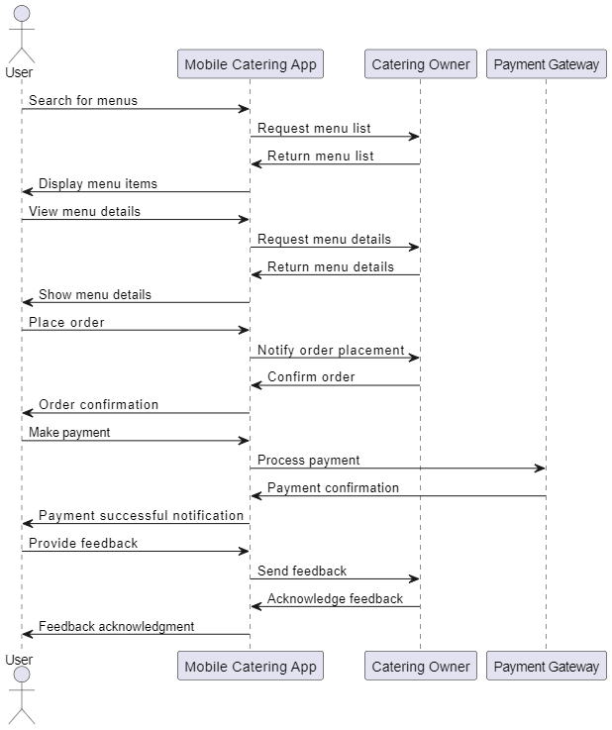
Sequence Diagram

FIGURE VI. SEQUENCE DIAGRAM

Figure VI illustrates the Sequence Diagram for the mobile catering app, detailing the interactions between the User, Catering Owner, and the system throughout the ordering process. The diagram captures key steps such as searching for menus, viewing details, placing orders, and processing payments. It shows how the User initiates actions, which prompt the Mobile Catering App to communicate with the Catering Owner and the Payment Gateway. Additionally, it highlights the feedback loop where the User provides reviews, allowing for ongoing interaction and improvement. This Sequence Diagram effectively represents the dynamic behavior of the app, emphasizing the flow of information and actions among the components involved in delivering a seamless user experience.

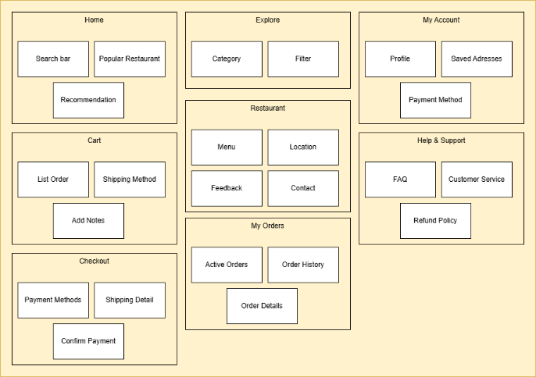
Wireframe

figure vii. WIREFRAME
Figure VII illustrates the wireframe includes key app pages: Home (search, recommendations, popular restaurants), Explore (categories, filters), My Account (profile, addresses, payment methods), Cart (orders, shipping, notes), Checkout (payment, shipping, confirmation), Restaurant (menu, location, feedback, contact), Help & Support (FAQ, customer service, refund policy), and My Orders (active orders, history, details).

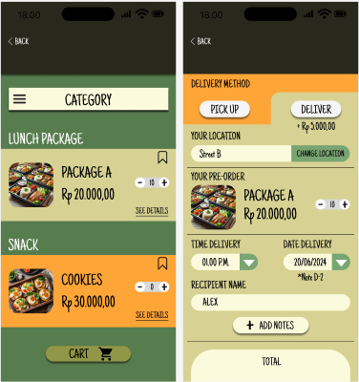
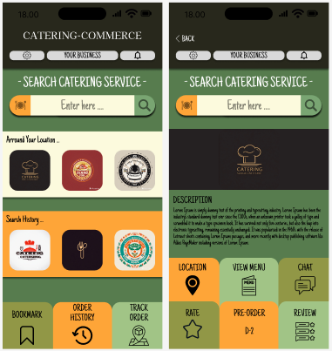
Design
(A) (B) (C) (D)

figure viii. DESIGN VIEW FOR CUSTOMER (A) & (B)HOME SCREEN, (C) VIEW MENU, & (D) PRE ORDER

Figure VIII represents the design of the catering application, showcasing its core functionalities and user interface design. Figure VIII illustrates the application from the customer’s point of view. This design serves as a visual guide to demonstrate the intended user experience and workflow of the mobile catering platform.
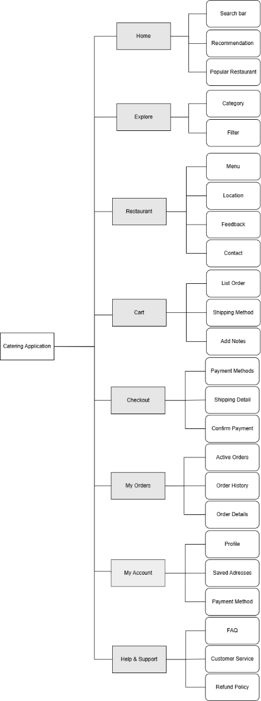

Sitemap

figure ix. SITEMAPS

Figure VII illustrates the sitemap of the catering application, highlighting key sections: Home (search, recommendations, popular restaurants), Explore (categories, filters), Restaurant (menu, location, feedback), Cart (orders, shipping, notes), Checkout (payment, shipping, confirmation), My Orders (active orders, history, details), My Account (profile, addresses, payment methods), and Help & Support (FAQ, customer service, refund policy). This structure provides a clear and organized flow for users to navigate through the app efficiently.

Conclusion
The rapid advancement of mobile technology has significantly transformed the food delivery industry in Indonesia, particularly through the development of mobile catering applications. This study has highlighted the dual role of these applications in ensuring both convenience and safety for users, which is especially critical in the post-pandemic era. By offering seamless food ordering, personalized recommendations, and real-time tracking, mobile catering apps have revolutionized consumer dining habits. Additionally, the integration of safety measures such as contactless payment systems, hygiene protocols, and delivery safety features has addressed the heightened concerns of modern consumers.
The comprehensive analysis of user experiences and industry practices underscores the importance of integrating user-friendly features and strict safety guidelines to build trust and enhance customer satisfaction. The findings suggest that mobile catering apps not only meet the evolving demands of Indonesian consumers but also have the potential to shape the future of food delivery services. As the industry continues to grow, it is imperative for developers and service providers to prioritize system quality, user satisfaction, and innovative safety measures to maintain a competitive edge and foster consumer loyalty.
In conclusion, mobile catering applications represent a significant innovation in the food service industry, offering a blend of convenience and safety that aligns with contemporary consumer expectations. The continued evolution and adoption of these digital platforms will likely play a pivotal role in the future landscape of food delivery in Indonesia.

References

[1] M. Syani and N. Werstantia, “PERANCANGAN APLIKASI PEMESANAN CATERING BERBASIS MOBILE ANDROID,” Jurnal Ilmiah Ilmu dan Teknologi Rekayasa, vol. 1, no. 2, 2020, doi: 10.31962/jiitr.v1i2.22.
[2] M. Keeble et al., “Use of online food delivery services to order food prepared away-from-home and associated sociodemographic characteristics: A cross-sectional, multi-country analysis,” Int J Environ Res Public Health, vol. 17, no. 14, pp. 1–17, Jul. 2020, doi: 10.3390/ijerph17145190.
[3] Y. S. Wang, T. H. Tseng, W. T. Wang, Y. W. Shih, and P. Y. Chan, “Developing and validating a mobile catering app success model,” Int J Hosp Manag, vol. 77, 2019, doi: 10.1016/j.ijhm.2018.06.002.
[4] I. Swarna, J. Purnama, and R. Anthony, “Cross-Platform Analysis and Development of Online Catering Platform (Kunyahku),” Journal of Applied Information …, 2020, [Online]. Available: http://journal.sgu.ac.id/ejaict/index.php/EJAICT/article/view/106
[5] T. Wu, “Catering to your concerns: Automatic generation of personalised security-centric descriptions for android apps,” ACM Transactions on Cyber-Physical Systems, vol. 3, no. 4, 2019, doi: 10.1145/3317699.
[6] T. Tasyabila, V. Sihombing, and ..., “Implementation of the RAD Method to build catering application Android-based,” Sinkron: jurnal dan …, 2022, [Online]. Available: https://jurnal.polgan.ac.id/index.php/sinkron/article/view/11421
[7] A. Spasić and L. Mićić, DIGITAL TECHNOLOGY′ S IMPACT ON USAGE OF MOBILE APPLICATION AT CATERING FACILITIES. doisrpska.nub.rs, 2022. [Online]. Available: https://doisrpska.nub.rs/index.php/NOEK/article/view/10242
[8] S. Ma, “Catering for Students’ Well-being during COVID-19 Social Distancing: A Case Study from a University Campus,” ACM International Conference Proceeding Series, pp. 146–153, 2022, doi: 10.1145/3524458.3547261.
[9] L. B. Cassar and F. Inguanez, “ARC: augmented reality for catering,” 2018 IEEE 8th International …, 2018, [Online]. Available: https://ieeexplore.ieee.org/abstract/document/8576165/
[10] X. Yang, “An Intelligent Catering Service Platform Based on the ‘android+J2EE,’” Proceedings - 2015 4th International Conference on Advanced Information Technology and Sensor Application, AITS 2015, pp. 24–27, 2016, doi: 10.1109/AITS.2015.13.
[11] E. Taylor, “A new method of HACCP for the catering and food service industry,” Food Control, 2008, [Online]. Available: https://www.sciencedirect.com/science/article/pii/S0956713507000461
[12] C. J. Lai and C. P. Tsai, “Design of introducing service robot into catering services,” Proceedings of the 2018 International Conference on …, 2018, doi: 10.1145/3208833.3208837.
[13] K. J. Baso, R. Sengkey, and Y. D. Y. Rindengan, “Perancangan Aplikasi Catering Berbasis Mobile,” Jurnal Teknik Elektro dan Komputer, vol. 9, no. 2, 2020.
[14] F. P. Nieh and C. Y. Pong, “Key success factors in catering industry management,” Актуальні проблеми економіки, 2012, [Online]. Available: http://www.irbis-nbuv.gov.ua/cgi-bin/irbis_nbuv/cgiirbis_64.exe?C21COM=2&I21DBN=UJRN&P21DBN=UJRN&IMAGE_FILE_DOWNLOAD=1&Image_file_name=PDF/ape_2012_4_47.pdf
[15] J. C. Chung, Y. F. Huang, M. W. Weng, and J. C. Lin, “The sustainable innovation design in catering service,” Sustainability (Switzerland), vol. 14, no. 1, 2022, doi: 10.3390/su14010278.
[16] A. Tufano, R. Accorsi, and R. Manzini, “A simulated annealing algorithm for the allocation of production resources in the food catering industry,” British Food Journal, 2020, doi: 10.1108/BFJ-08-2019-0642.
[17] Y. Gusev, T. Polovova, and A. Pinsky, “Digital innovations of public catering enterprises: the need and opportunities,” Proceedings of the 3rd International …, 2021, doi: 10.1145/3527049.3527087.
[18] G. Arvindaraj, “Opportunities of Machine Learning Techniques in the Catering Industry- A Survey,” Proceedings of the 2023 2nd International Conference on Electronics and Renewable Systems, ICEARS 2023, pp. 1405–1409, 2023, doi: 10.1109/ICEARS56392.2023.10085004.
[19] G. Arvindaraj, B. Manikandan, R. Rokesh, and ..., “Opportunities of Machine Learning Techniques in the Catering Industry-A Survey,” … on Electronics and …, 2023, [Online]. Available: https://ieeexplore.ieee.org/abstract/document/10085004/
[20] P. A. Rohmalia and Y. M. Djajalaksana, “Pengelolaan Bisnis Catering dengan Memanfaatkan Sistem Informasi Berbasis Web (Studi Kasus pada Anggun Catering).”
[21] Y. Jiang and Z. Shen, “Study on the Application of CVP Analysis in Catering Industry,” 2nd International Conference on Contemporary …, 2017, [Online]. Available: https://www.atlantis-press.com/proceedings/iccessh-17/25878726
[22] S. Li, D. Xu, Y. Liu, R. Wang, and ..., “Identification Method of Influencing Factors of Hospital Catering Service Satisfaction Based on Decision Tree Algorithm,” Applied Bionics and …, 2022, doi: 10.1155/2022/6293908.
[23] Y. Shteyn and J. Moonen, “Digital content catering system,” US Patent App. 09/971,474, 2003, [Online]. Available: https://patents.google.com/patent/US20030069964A1/en
[24] I. Swarna, J. Purnama, and R. Anthony, “Cross-Platform Analysis and Development of Online Catering Platform (Kunyahku),” Journal of Applied Information …, 2020, [Online]. Available: http://journal.sgu.ac.id/ejaict/index.php/EJAICT/article/view/106
[25] W. Zhen-fang and L. Yi-jie, “Research of Web Services based on GIS in the mobile catering service,” 2010 IEEE International Conference on …, 2010, [Online]. Available: https://ieeexplore.ieee.org/abstract/document/5552255/
[26] B. Susanto, F. L. Gaol, S. Si, and M. Kom, “Web-based catering marketplace business plan: Cateringku. com,” Issues and Trends in …, 2018, doi: 10.1201/9781315148700-6.
[27] C. Yan, S. T. Grigoryevna, and X. Liang, “Methods and Applications of Investment Decisions in the Catering Industry,” American Journal of …, 2024, [Online]. Available: https://journals.e-palli.com/home/index.php/ajase/article/view/2624
[28] T. Lv, Z. Gan, P. Wei, and T. Zhao, “The Design and Implementation of Catering Safety Tracing System Based on Block Chain,” 2019 2nd International Conference …, 2019, [Online]. Available: https://ieeexplore.ieee.org/abstract/document/9095971/
[29] E. N. Sulastri, D. S. Yudha, and A. R. Efrat, “PENERAPAN METODE USER CENTERED DESIGN PADA PERANCANGAN DESAIN UI/UX APLIKASI MARKETPLACE CATERING,” Jurnal Informatika dan Teknik Elektro Terapan, vol. 12, no. 3, Aug. 2024, doi: 10.23960/jitet.v12i3.4702.
[30] P. M.-A.-R. A. Ras, S. Popescu, M. Mocanu, and ..., “SmartMeal: A scalable catering application,” rochi.utcluj.ro, [Online]. Available: https://rochi.utcluj.ro/ijusi/articles/IJUSI-15-1-Abu-Ras.pdf
[31] W. Jiawen, “Digital Transformation in Catering Industry: Current Developments and Policy Recommendations,” Academic Journal of Business &Management, [Online]. Available: https://francis-press.com/uploads/papers/3qNoFVwRIteNaJVWCK58d8UnV53K82wmJfqSw2Bq.pdf
[32] Y. Xiaozhou, X. Liang, and M. Hongzhi, “An Intelligent Catering Service Platform Based on the" Android+ J2EE",” … and Sensor Application …, 2015, [Online]. Available: https://ieeexplore.ieee.org/abstract/document/7396437/
[33] E. A. Pyanikova, A. E. Kovaleva, and ..., “Digital technologies in public catering Industry (regional aspect),” … Trends and the Digital …, 2019, [Online]. Available: https://www.atlantis-press.com/proceedings/mtde-19/125908876

